Unit 5.1 FP and MP in the short run

Core Questions
- If an economy is in long-run equilibrium, which of the following combinations of policy actions will result in inflation?
- Increasing the money supply and increasing government spending
- Increasing the discount rate and decreasing income taxes
- Increasing the required reserve ratio and increasing the discount rate
- Selling government bonds on the open market and decreasing government spending
- Buying government bonds on the open market and decreasing government spending

- Given the situation illustrated in the graph and holding all other influences constant, which of the following policies will restore the macroeconomic equilibrium to full employment?
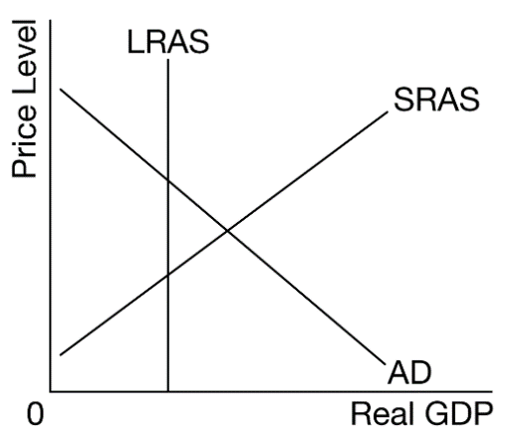
- A contractionary fiscal policy and an expansionary monetary policy
- A contractionary fiscal policy and a contractionary monetary policy
- An expansionary fiscal policy and a contractionary monetary policy
- An expansionary fiscal policy and an expansionary monetary policy
- An expansionary fiscal policy without monetary policy

- Country X’s economy is in recession. Which of the following combinations of fiscal and monetary policy actions would move the economy toward full employment in the short run?
- A decrease in government spending and an increase in the discount rate
- A decrease in income taxes and targeting a higher interest rate on overnight interbank loans
- A decrease in income taxes and a sale of government bonds on the open market by the country’s central bank
- An increase in government spending and a decrease in the required reserve ratio
- An increase in income taxes and a purchase of government bonds on the open market by the country’s central bank

- Which of the following monetary and fiscal policy mixes will reduce unemployment?
- Buying government bonds in the open market and increasing taxes
- Buying government bonds in the open market and decreasing taxes
- Selling government bonds in the open market and increasing government spending
- Selling government bonds in the open market and decreasing government spending
- Selling government bonds in the open market and increasing taxes

- Which of the following combinations of fiscal and monetary policies will correct a severe recession?
- Increasing income tax rates and decreasing the money supply
- Increasing both the income tax rates and the money supply
- Decreasing both the income tax rates and the money supply
- Decreasing income tax rates and increasing the money supply
- Decreasing income tax rates and increasing the federal funds rate

- If the government decreases spending while the country’s central bank buys bonds on the open market, which of the following will definitely occur?
- The aggregate demand curve will shift to the right.
- The aggregate demand curve will shift to the left.
- The short-run aggregate supply curve will shift to the right.
- Interest rates will fall.
- Interest rates will rise.

- Which of the following combinations of fiscal and monetary policy will reduce the price level?
 | Fiscal Policy | Monetary Policy
A | Increased government spending | Buying government bonds
B | Increased government spending | Selling government bonds
C | Decreased government spending | Buying government bonds
D | Decreased government spending | Selling government bonds
E | Decreasing taxes | Decreasing the discount rate

1 | A | 6 | D
2 | B | 7 | D
3 | D
4 | B
5 | D

